* **Amit shah holding: -**
* **Source** of amit shah holding :- **amit shah Affidavit:-**
* **Eci site =** [Affidavit Portal | Election Commission of India (eci.gov.in)](https://www.eci.gov.in/affidavit-portal)
* **ECI candidate affidavit page**:- [Election Commission of India (eci.gov.in)](https://affidavit.eci.gov.in/?page=5)
* **Amit shah affidavit:-** [Election Commission of India (eci.gov.in)](https://affidavit.eci.gov.in/show-) **pdf (both listed and unlisted stock holdings of amit shah available) as of 19 April 2024**
* **Amit shah listed company total holdings (excel sheet): - 181 holding :-** [page 1.xlsx](https://1drv.ms/x/s!At5WivVSSLb9kUFDOkw8qJRAivqs?e=GKEChF) **TOTAL PORFOLIO WORTH OF AMIT SHAH = 174374913.7 (17 Cr 43 Lac 74K AND 913)**

**Top 10 holding based on the amount invested:**- 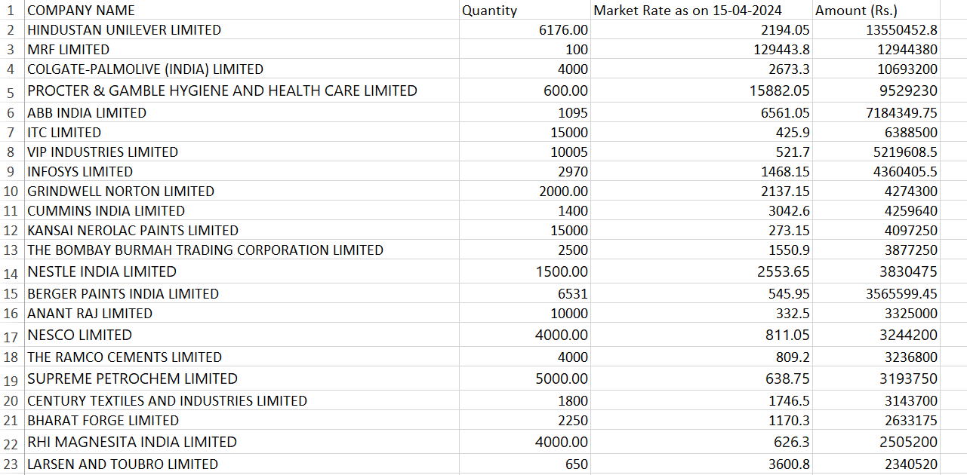

* **The amounts are not expressed notation** like in crore (cr) or lakh (lac); they are directly written.

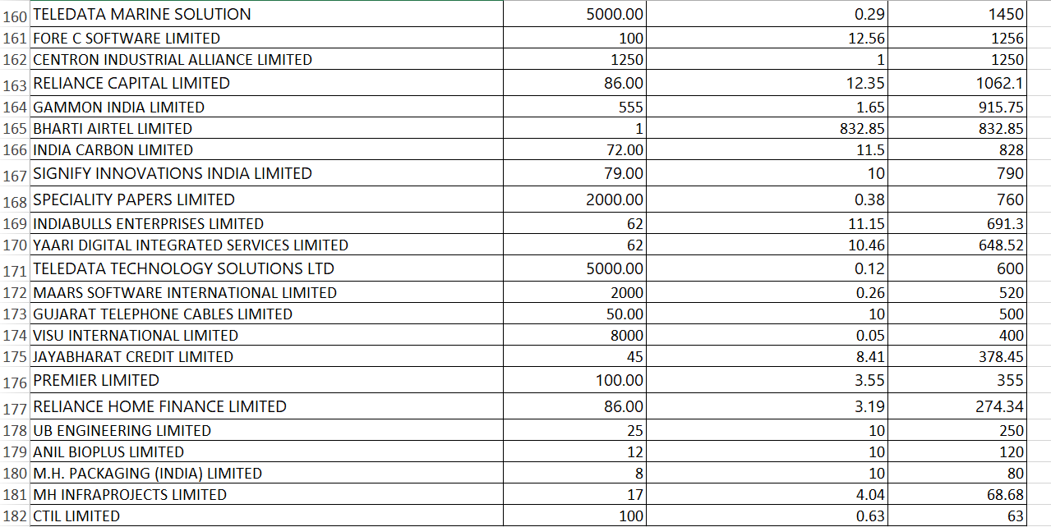

**Bottom 10 Holdings based on amount invested: -**

* **The amounts are not expressed notation** like in crore (cr) or lakh (lac); they are directly written.
* **Top 20 holding based on quantity of shares:**- 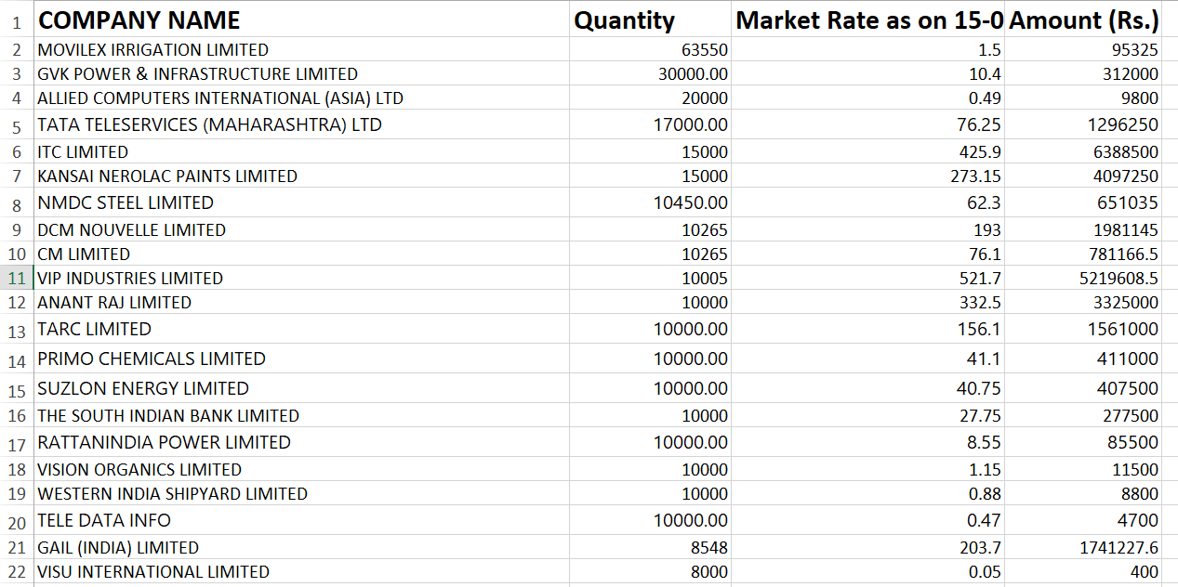
* **Quantity wont matter as there are penny stocks too:----**
* **Bottom 20 holding based on quantity of shares:**- 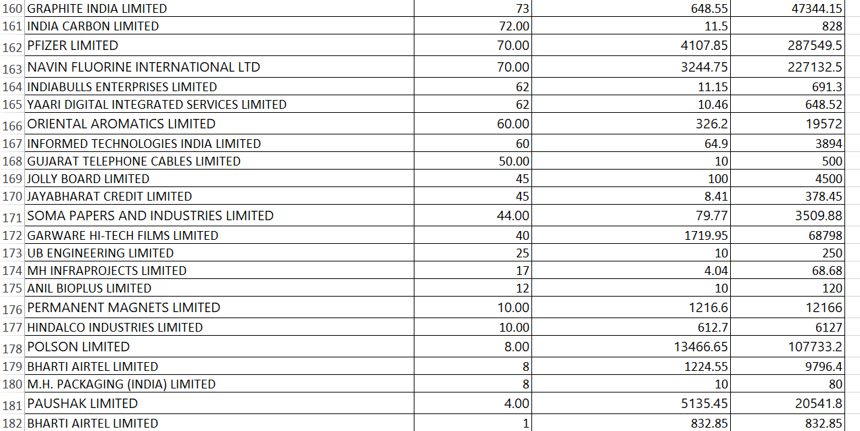
* **Quantity wont matter as there are penny stocks too:----**

**Decoding amit shah portfolio real or fake**

* First point is that The total investment amount of the amit on the listed shares are nearly around 17crore, but what I belive is that as a high level politician 17cr is very less, as we have seen in past that in IT raid of the low level politicion only the amounts are more than 50 cr.
* Second as we know the bond between the amit shah and the Gautam adani is very good, but in the amit shah portfolio there is not even a single share of any of the adani group share.
* Third, if we see the least amount on which the amit has invested in are 120rs, 63rs, 60rs, etc and the no. of shares shares are like 1 share, 4 – 8 shares like this , I mean who will invest like this
* Fourth, out of the total 181 stocks in which the amit shah has invested as shown in his afadavit, data is avialible of only 126 stocks I have checked on both the NSE and on the BSE site
* Fifth, on his afadavit the price of the shares that he has invested is shown of the date as Market Rate as on 15-04-2024, but when I compared on the price chart the price was notmatch to it, so by looking at all this points its seem to be a bogus portfolio, **just done for the sake of the formalities of the lok shabha election**